

DID YOU KNOW?



SOFT SKILLS CONTRIBUTE
MOST TO CAREER SUCCESS.

5 MOST IMPORTANT SOFT SKILLS

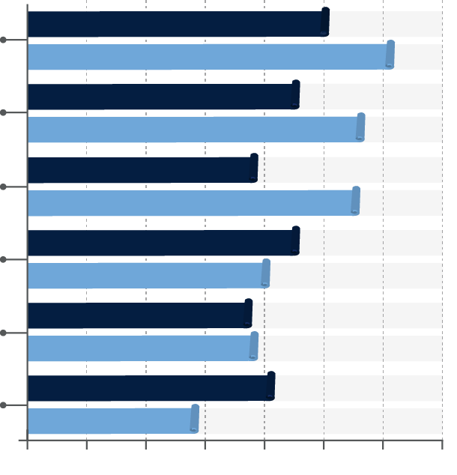
51%%
Team-working skills (coordinating
& collaborating with others)

62%%

46%%
Analytical reasoning/
critical thinking
57%%

39%%
Complex problem solving
56%%

46%%
Agility and adaptability
41%%

38%%
Ethical judgment
39%2%%

42%%
Decision-making
29%%

70%
60%
50%
40%
30%
20%
10%
0%
Source: Bloomberg
ACADEMIC INSTITUTION N=100
CORPORATION N=100


Start building the soft skills employers want!
Get CareerPrepped. Get Noticed.



[INSTITUTION] is providing CareerPrepped for FREE to all its students & alumni.
Visit www.careerprepped.com/group and sign up using group code [GROUP CODE]

© CareerPrepped. All rights reserved
www.careerprepped.com

